Analysis and Proposed solution for order services

Analysis and Proposed solution for order services 1
Abbreviation 1
Introduction 1
Issues found 1
Propose Solution 4
Conclusion 4

Abbreviation
UI | User Interface
DB | Database
EF | Entity Framework
CQRS | Command Query Responsibility Segregation

Introduction
The goal of this document is to propose a simple, unambitious yet effective solution to overcome the experienced issues with the current implementation and of course fulfill exactly our business needs. It takes into account the following:
- The business requirements
- The structure is easy to modify and easy for the maintanace
- Development and maintenance costs in terms of time and people
- Easy to scale and add new features without a negative change impact to the system: the simpler the system, the more adaptive and easier to scale

Issues found
After looking carefully at the source code for legacy order services. From my point of view, I do have several things that needs to be re-implemented and improve.
Let’s come up with the details below.
- Syntax code: redundant “)” at the end
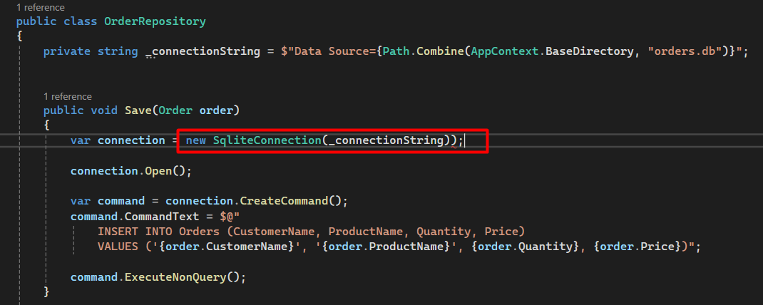
- The input does not validate for customerName, productName (required, existed or not) Solution: Keep in mind that input data must validate the input before do anything else
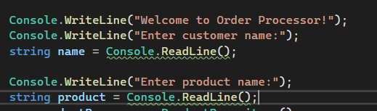
- Price should not be got from Input. Because end-user can change the price from UI
Note: Avoid sensitive information (Price) can be changed from end-user (UI)
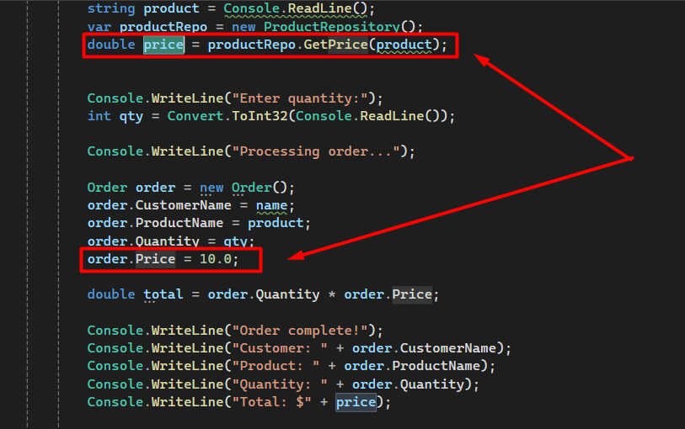
- The price is hard code, it doesn’t from DB. Get price from DB but it doesn’t use anywhere and print to the wrong place at Total output
Note: Don’t hard code for important data of the workflow, also print the right value for the information that we want to verify the output
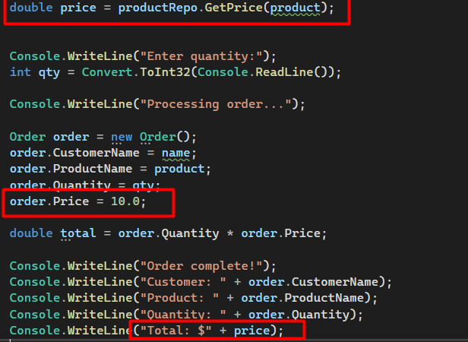
- The connection from DB hasn’t been closed after Opened that can lead to memory leak issue.
Solution: use keyword using whenever it has the call to DB, use the using keyword with an object that implements IDisposable (like DbContext), it ensures that the object is automatically disposed at the end of the block, even if an exception occurs.
- One of the biggest problems is SQL injection if it uses commandText like this.
Solution: change to use EF Core to avoid this dangerous issue.
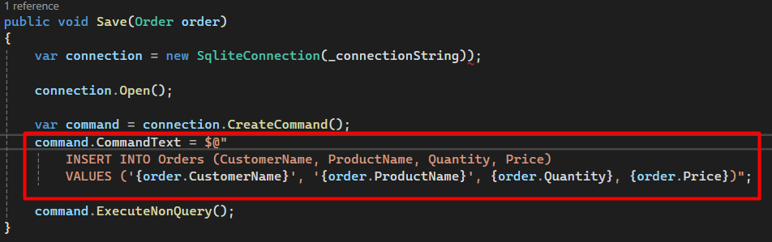
- Application is running synchronously, it could be getting the Blocking I/O (DB, ThreadSleep)
Solution: change the application to asynchronous (async / await)
- The function GetPrice in ProductRepository, it is using Dictionary (thread – unsafe) it can be blocked or getting the error whenever multiple process access to this variable at the same time.
Solution: use ConcurrentDictionary (Represents a thread-safe collection of keys and values also may be used concurrently from multiple threads)
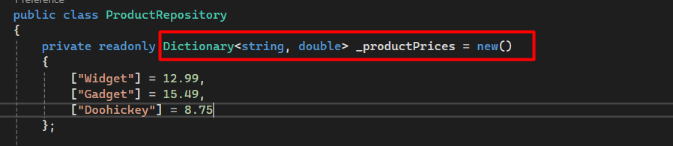
- No separation of concerns, implementation the code and business inside main function of Program.cs file.

Propose Solution
Technical in use
- CQRS partern: is a design pattern that separates read (Query) and write (Command) operations into distinct models, improving scalability, clarity, and flexibility
- MediatR pattern: is a simple .NET library that helps implement the Mediator design pattern. It decouples request/response logic in your app by sending messages (commands, queries, notifications) to handlers, rather than calling services directly
- EF Core: is a modern Object-Relational Mapper (ORM) for .NET. It lets you interact with databases using C# objects, avoiding most raw SQL (Supports LINQ, async/await, migrations)
- Move to Asynchronous (async/await) without blocking thread: Asynchronous programming allows your application to perform non-blocking operations
- Channel (In memory Queue): System.Threading.Channels provides thread-safe, high-performance in-memory queues for communication between asynchronous producers and consumers

Conclusion
Let’s check out on the public repository bellow, to see what I did change and optimize for this legacy order service

